Assignment 1
Host website using Jenkin Job
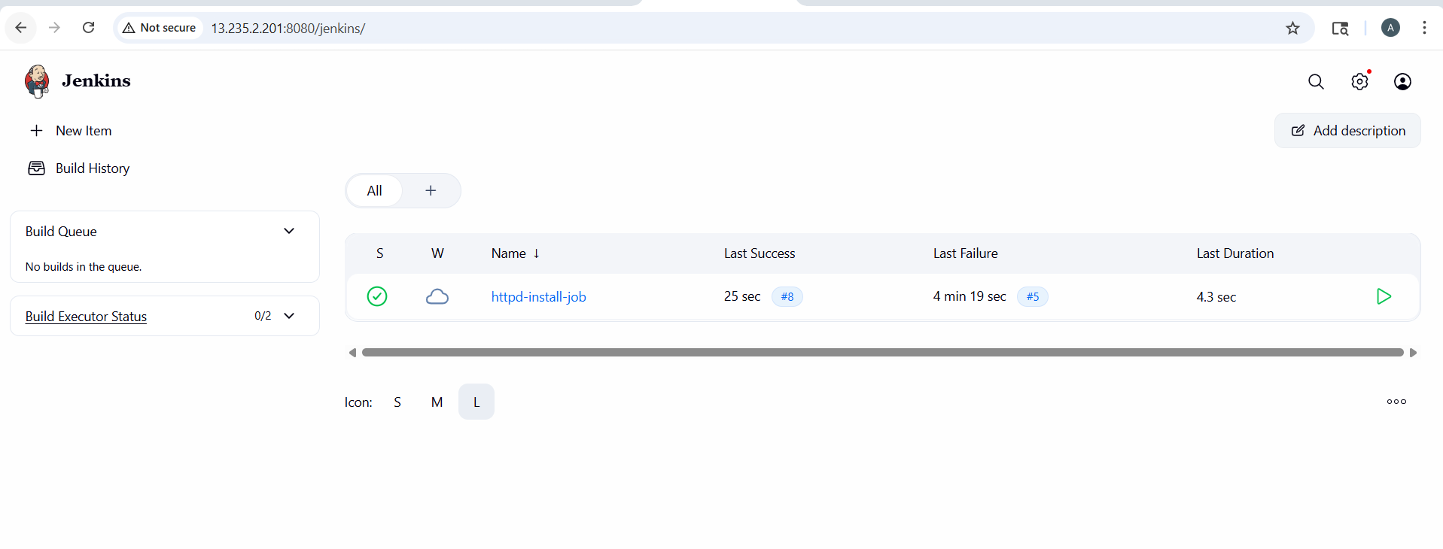
- Store HTML in GitHub
- Jenkins pulls it and copies to /var/www/html
